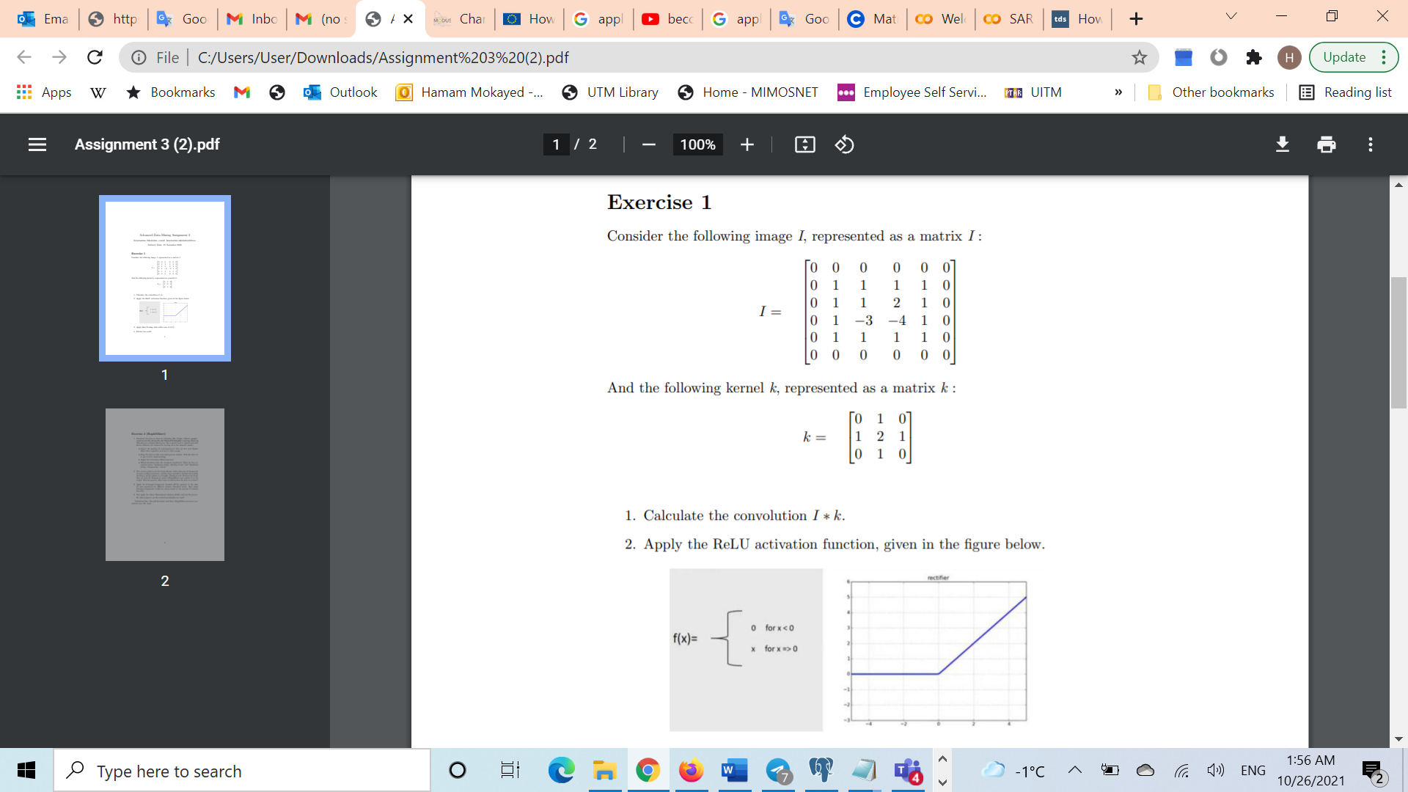

1. Calculate the convolution I * k.

I * k = 1. 0 0 0 * 0 1 0 = 0 0 0 (SUM)🡪 4

0 1 1 1 2 1 0 2 1

0 1 1 0 1 0 0 1 0

2. 000 =000 🡪 5

111 121

112 010

3. 🡪 6

Ans: 4 5 6 4

5 3

2. Apply the ReLU activation function, given in the figure below.

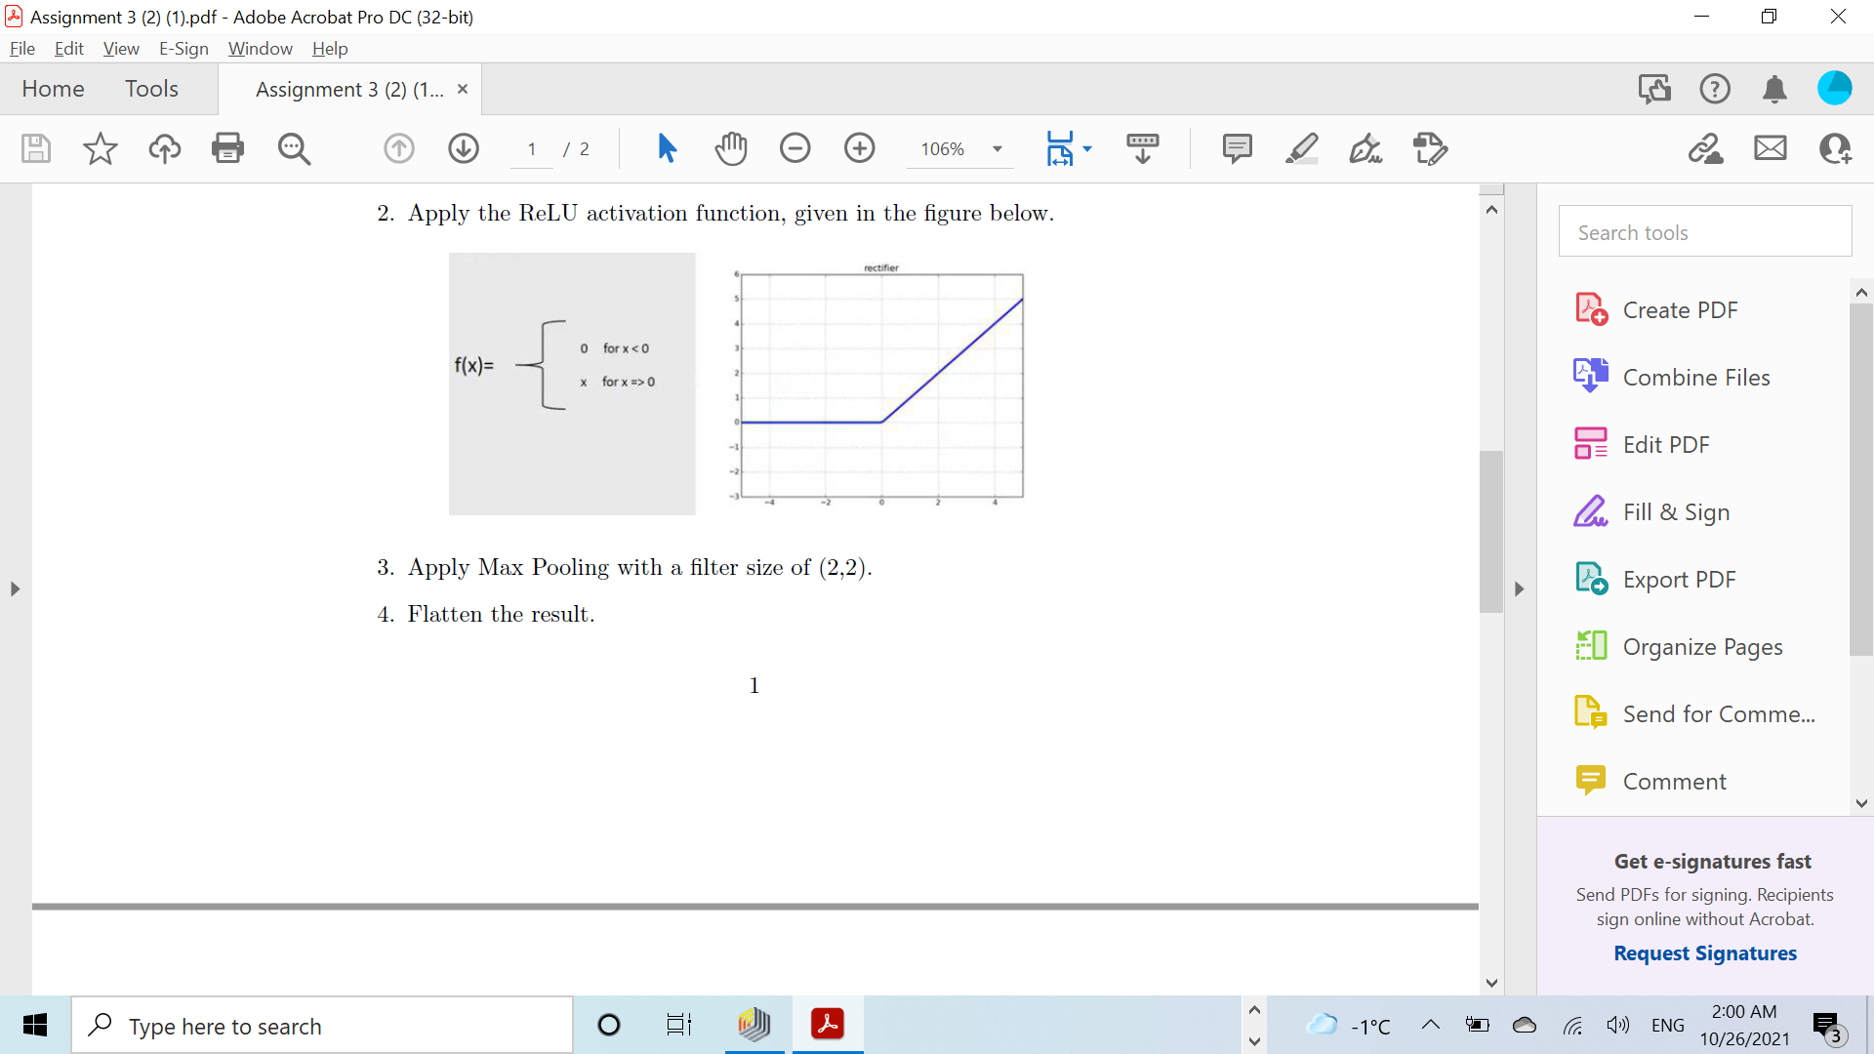

For eg, 🡪 4 5 6 4

4 5 6 4 5 3 0 3

5 3 -5 3 6 7 0 0

6 7 -1 0 1 3 0 0

1 4 -7 -3

3. Apply Max Pooling with a filter size of (2,2).

5 6

7 0

4. Flatten the result.

5

6

7

0

5. Explore the Neural network in rapidMiner using the below link

https://docs.rapidminer.com/latest/studio/operators/modeling/predictive/neural_nets/neural_net.html